Operations Management, 10e, Global Edition (Heizer/Render)
Module A Decision-Making Tools

1) Analytic decision making is based on logic and considers all available data and possible alternatives.
Answer: TRUE
Diff: 1
Topic: The decision process in operations
AACSB: Analytic Skills
Objective: no LO

2) The last step in the analytic decision process clearly defines the problem and the factors that influence it.
Answer: FALSE
Diff: 1
Topic: The decision process in operations
AACSB: Analytic Skills
Objective: no LO

3) A state of nature is an occurrence of a situation over which the decision maker has little or no control.
Answer: TRUE
Diff: 1
Topic: Fundamentals of decision making
Objective: LO-Module A-1

4) In a decision tree, a square symbol represents a state of nature node.
Answer: FALSE
Diff: 2
Topic: Fundamentals of decision making
Objective: LO-Module A-1

5) If a decision maker can assign probabilities of occurrence to the states of nature, then the decision is being made under conditions of uncertainty.
Answer: FALSE
Diff: 2
Topic: Types of decision-making environments
Objective: LO-Module A-3

6) An example of a conditional value would be the payoff from selecting a particular alternative when a particular state of nature occurs.
Answer: TRUE
Diff: 2
Topic: Types of decision-making environments
Objective: LO-Module A-3
7) The maximax criterion of decision making requires that all decision alternatives have an equal probability of occurrence.
Answer: FALSE
Diff: 1
Topic: Types of decision-making environments
Objective: LO-Module A-3
8) The maximin criterion is pessimistic, while the maximax criterion is optimistic.
Answer: TRUE
Diff: 1
Topic: Types of decision-making environments
Objective: LO-Module A-3

9) If a decision maker knows for sure which state of nature will occur, he/she is making a decision under certainty.
Answer: TRUE
Diff: 2
Topic: Types of decision-making environments
Objective: LO-Module A-3

10) The expected value with perfect information assumes that all states of nature are equally likely.
Answer: FALSE
Diff: 1
Topic: Types of decision-making environments
Objective: LO-Module A-5

11) An example of expected monetary value would be the payoff from selecting a particular alternative when a particular state of nature occurs.
Answer: FALSE
Diff: 2
Topic: Decision tables
Objective: LO-Module A-4

12) The expected monetary value of a decision alternative is the sum of all possible payoffs from the alternative, each weighted by the probability of that payoff occurring.
Answer: TRUE
Diff: 1
Topic: Types of decision-making environments
Objective: LO-Module A-4

13) If a decision maker has to make a certain decision only once, expected monetary value is a good indication of the payoff associated with the decision.
Answer: FALSE
Diff: 2
Topic: Types of decision-making environments
Objective: LO-Module A-4
14) The expected value of perfect information is the same as the expected value with perfect information.
Answer: FALSE
Diff: 2
Topic: Types of decision-making environments
Objective: LO-Module A-5

15) Decision trees and decision tables can both solve problems requiring a single decision, but decision tables are the preferred method when a sequence of decisions is involved.
Answer: FALSE
Diff: 1
Topic: Decision trees
Objective: LO-Module A-6

16) In a decision tree, the expected monetary values are computed by working from right to left.
Answer: TRUE
Diff: 2
Topic: Decision trees
Objective: LO-Module A-6

17) Which of the following is not considered a step in the decision-making process?
A) Clearly identify the problem.
B) Select the best alternative.
C) Develop objectives.
D) Evaluate alternatives.
E) Minimize costs whenever possible.
Answer: E
Diff: 2
Topic: The decision process in operations
Objective: no LO

18) The first step, and a key element, in the decision-making process is to
A) consult a specialist
B) clearly define the problem
C) develop objectives
D) monitor the results
E) select the best alternative
Answer: B
Diff: 1
Topic: The decision process in operations
Objective: no LO
19) The last step of the decision-making process is to
A) develop a model
B) evaluate each alternative
C) pick the best alternative
D) implement the decision
E) check the decision with senior management
Answer: D
Diff: 2
Topic: The decision process in operations
Objective: no LO

20) A square node on a decision tree infers that
A) the node splits into various states of nature, of which only one will occur
B) there are several alternatives available
C) the manager must pick choose an alternative
D) both B and C
E) A, B, and C
Answer: D
Diff: 2
Topic: Fundamentals of decision making
Objective: LO-Module A-1

21) The following decision tree has how many state of nature nodes

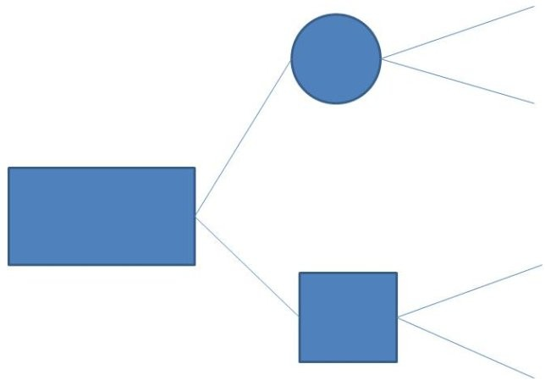

A) 0
B) 1
C) 2
D) 3
E) 4
Answer: B
Diff: 2
Topic: Fundamentals of decision making
Objective: LO-Module A-1
22) In terms of decision theory, an occurrence or situation over which the decision maker has no control is called a(n)
A) decision under uncertainty
B) decision tree
C) state of nature
D) alternative
E) none of the above
Answer: C
Diff: 1
Topic: Fundamentals of decision making
Objective: LO-Module A-1

23) A tabular presentation that shows the outcome for each decision alternative under the various possible states of nature is called a(n)
A) isoquant table
B) payback period matrix
C) payoff table
D) feasible region
E) decision tree
Answer: C
Diff: 1
Topic: Decision tables
Objective: LO-Module A-2

24) The outcome of an alternative/state of nature combination is a(n)
A) price
B) conditional value
C) expected value
D) conditional probability
E) All of the above are correct.
Answer: B
Diff: 2
Topic: Decision tables
Objective: LO-Module A-2

25) Doing nothing would yield how much profit if favorable market conditions prevail according to the following decision table?

Alternative | Favorable market | Unfavorable Market
Do Nothing | $20,000 | -$10,000

A) $5,000
B) $20,000
C) -$10,000
D) $0
E) unable to determine
Answer: B
Diff: 1
Topic: Decision tables
Objective: LO-Module A-2
26) The decision criterion that would be used by an optimistic decision maker solving a problem under conditions of uncertainty would be the
A) expected monetary value criterion
B) equally likely criterion
C) maximax criterion
D) maximin criterion
E) minimin criterion
Answer: C
Diff: 2
Topic: Types of decision-making environments
Objective: LO-Module A-3

27) A decision maker who uses the maximin criterion when solving a problem under conditions of uncertainty is
A) an optimist
B) a pessimist
C) an economist
D) an optometrist
E) making a serious mistake; maximin is not appropriate for conditions of uncertainty
Answer: B
Diff: 2
Topic: Types of decision-making environments
Objective: LO-Module A-3

28) Expected monetary value is most appropriate for problem solving that takes place
A) when conditions are average
B) when all states of nature are equally likely
C) when all alternatives are equally likely
D) under conditions of uncertainty
E) under conditions of risk
Answer: E
Diff: 2
Topic: Types of decision-making environments
Objective: LO-Module A-4

29) Suppose that there are three options facing a manager. He may either build a large plant for a value of $20,000 in profit, a small plant for $10,000 in profit, or do nothing and make $3,000. What is the EMV of the decision?
A) $20,000
B) $10,000
C) $3,000
D) $33,000
E) $11,000
Answer: A
Diff: 2
Topic: Types of decision-making environments
Objective: LO-Module A-4
30) There are three equally likely states of nature (High, Medium, and Low demand). If the large factory will post profits of $50,000, $25,000, and - $10,000 under these states of nature, respectively, what is the EMV of the factory?
A) $50,000
B) $25,000
C) $28,333.33
D) $21,666.67
E) none of the above
Answer: D
Diff: 2
Topic: Types of decision-making environments
Objective: LO-Module A-4

31) A plant manager wants to know how much he should be willing to pay for perfect market research. Currently there are two states of nature facing his decision to expand or do nothing. Under favorable market conditions the manager would make $100,000 for the large plant and $5,000 for the small plant. Under unfavorable market conditions the large plant would lose $50,000 and the small plant would make $0. If the two states of nature are equally likely, how much should he pay for perfect information?
A) $0
B) $25,000
C) $50,000
D) $100,000
E) unable to determine
Answer: B
Diff: 2
Topic: Types of decision-making environments
Objective: LO-Module A-5

32) The expected value with perfect information
A) is appropriate when solving problems under conditions of certainty
B) requires that each decision alternative have a known probability of occurrence
C) is an input into the calculation of the expected value of perfect information
D) is the average of the maximax and the maximin
E) none of the above
Answer: C
Diff: 2
Topic: Types of decision-making environments
Objective: LO-Module A-5
33) The difference between the expected payoff under perfect information and the maximum expected payoff under risk is
A) expected monetary value
B) economic order quantity
C) expected value of perfect information
D) PERT
E) expected monetary payoff
Answer: C
Diff: 2
Topic: Types of decision-making environments
Objective: LO-Module A-5

34) The likelihood that a decision maker will ever receive a payoff precisely equal to the EMV when making any one decision is
A) low (near 0%)
B) high (near 100%)
C) dependent upon the number of alternatives
D) dependent upon the number of states of nature
E) none of the above
Answer: A
Diff: 2
Topic: Types of decision-making environments
Objective: LO-Module A-4

35) The expected value of perfect information (EVPI) is the
A) payoff for a decision made under perfect information
B) payoff under minimum risk
C) average expected payoff
D) difference between the payoff under perfect information and the payoff under risk
E) none of the above
Answer: D
Diff: 2
Topic: Types of decision-making environments
Objective: LO-Module A-5
36) A decision-maker using the maximax criterion on the problem below would choose Alternative __________ because the maximum of the row maximums is __________.

 | States of Nature
 | 1 | 2 | 3
Alternative A | 50 | 55 | 60
Alternative B | 30 | 50 | 80
Alternative C | 70 | 80 | 70
Alternative D | -100 | -10 | 140

A) A; 60
B) B; 80
C) C; 70
D) D; -100
E) D; 140
Answer: E
Diff: 2
Topic: Types of decision-making environments
AACSB: Analytic Skills
Objective: LO-Module A-3

37) A decision-maker using the maximin criterion on the problem below would choose Alternative __________ because the maximum of the row minimums is __________.

 | States of Nature
 | 1 | 2 | 3
Alternative A | 50 | 55 | 60
Alternative B | 30 | 50 | 80
Alternative C | 70 | 80 | 70
Alternative D | -100 | -10 | 140

A) A; 55
B) B; 30
C) C; 70
D) D; 140
E) D; 10
Answer: C
Diff: 2
Topic: Types of decision-making environments
AACSB: Analytic Skills
Objective: LO-Module A-3
38) The highest value for the equally likely criterion is __________; this occurs with alternative __________.

 | States of Nature
Alternatives | S1 | S2
Option 1 | $10,000 | $30,000
Option 2 | $5,000 | $45,000
Option 3 | $-4,000 | $60,000

A) $20,000; Option 1
B) $25,000; Option 2
C) $28,000; Option 3
D) $32,000; Option 3
E) $60,000; Option 3
Answer: C
Diff: 2
Topic: Types of decision-making environments
AACSB: Analytic Skills
Objective: LO-Module A-3

39) What is the EMV for Option 1 in the following decision table?

 | States of Nature
Alternatives | S1 | S2
p | .3 | .7
Option 1 | 15,000 | 20,000
Option 2 | 10,000 | 30,000

A) 15,000
B) 17,000
C) 17,500
D) 18,500
E) 20,000
Answer: D
Diff: 1
Topic: Types of decision-making environments
AACSB: Analytic Skills
Objective: LO-Module A-4
40) The expected value with perfect information is
A) the maximum EMV for a set of alternatives
B) the same as the expected value of perfect information
C) valuable in situations involving risk
D) the average return obtained when the decision maker knows which state of nature is going to occur before the decision is made
E) obtained using conditional probabilities
Answer: D
Diff: 2
Topic: Types of decision-making environments
Objective: LO-Module A-5

41) What is the EMV for Option 2 in the following decision table?

 | States of Nature
Alternatives | S1 | S2
p | .3 | .7
Option 1 | 15,000 | 20,000
Option 2 | 10,000 | 30,000

A) 10,000
B) 16,000
C) 20,000
D) 24,000
E) 30,000
Answer: D
Diff: 2
Topic: Types of decision-making environments
AACSB: Analytic Skills
Objective: LO-Module A-4
42) What is the EMV for Option 1 in the following decision table?

 | States of Nature
Alternatives | S1 | S2
p | .4 | .6
Option 1 | 10,000 | 30,000
Option 2 | 5,000 | 45,000
Option 3 | -4,000 | 60,000

A) 10,000
B) 18,000
C) 20,000
D) 22,000
E) 30,000
Answer: D
Diff: 2
Topic: Types of decision-making environments
AACSB: Analytic Skills
Objective: LO-Module A-4

43) What is the EMV for Option 2 in the following decision table?

 | States of Nature
Alternatives | S1 | S2
p | .4 | .6
Option 1 | 10,000 | 30,000
Option 2 | 5,000 | 45,000
Option 3 | -4,000 | 60,000

A) 5,000
B) 21,000
C) 25,000
D) 29,000
E) 45,000
Answer: D
Diff: 2
Topic: Types of decision-making environments
AACSB: Analytic Skills
Objective: LO-Module A-4
44) What is the expected value with perfect information of the following decision table?

 | States of Nature
Alternatives | S1 | S2
p | .4 | .6
Option 1 | 10,000 | 30,000
Option 2 | 5,000 | 45,000
Option 3 | -4,000 | 60,000

A) 5,000
B) 10,000
C) 40,000
D) 60,000
E) 70,000
Answer: C
Diff: 2
Topic: Types of decision-making environments
AACSB: Analytic Skills
Objective: LO-Module A-5

45) What is the EMV for Option 1 in the following decision table?

 | States of Nature
Alternatives | S1 | S2
p | .6 | .4
Option 1 | 200 | 300
Option 2 | 50 | 350

A) 200
B) 240
C) 250
D) 260
E) 300
Answer: B
Diff: 2
Topic: Types of decision-making environments
AACSB: Analytic Skills
Objective: LO-Module A-4
46) What is the EMV for Option 2 in the following decision table?

 | States of Nature
Alternatives | S1 | S2
p | .6 | .4
Option 1 | 200 | 300
Option 2 | 50 | 350

A) 50
B) 100
C) 170
D) 200
E) 350
Answer: C
Diff: 2
Topic: Types of decision-making environments
AACSB: Analytic Skills
Objective: LO-Module A-4

47) What is the expected value with perfect information in the following decision table?

 | States of Nature
Alternatives | S1 | S2
p | .6 | .4
Option 1 | 200 | 300
Option 2 | 50 | 350

A) 50
B) 200
C) 260
D) 300
E) 350
Answer: C
Diff: 2
Topic: Types of decision-making environments
AACSB: Analytic Skills
Objective: LO-Module A-5
48) What is the expected value of perfect information of the following decision table?

 | States of Nature
Alternatives | S1 | S2
p | .6 | .4
Option 1 | 200 | 300
Option 2 | 50 | 350

A) 0
B) 20
C) 50
D) 150
E) 200
Answer: B
Diff: 2
Topic: Types of decision-making environments
AACSB: Analytic Skills
Objective: LO-Module A-5

49) A retailer is deciding how many of a certain product to stock. The historical probability distribution of sales for this product is 0 units, 0.2; 1 unit, 0.3; 2 units, 0.4, and 3 units, 0.1. The product costs $8 per unit and sells for $25 per unit. The conditional value for the decision alternative "Stock 3" and state of nature "Sell 1" is
A) 1.4 units
B) $1 profit
C) $25 profit
D) $-8 profit
E) none of the above
Answer: B
Diff: 2
Topic: Types of decision-making environments
AACSB: Analytic Skills
Objective: LO-Module A-4

50) A retailer is deciding how many of a certain product to stock. The historical probability distribution of sales for this product is 0 units, 0.2; 1 unit, 0.3; 2 units, 0.4, and 3 units, 0.1. The product costs $8 per unit and sells for $25 per unit. The largest conditional value (profit) in the entire payoff table for this scenario is
A) $-24 profit
B) $-8 profit
C) $17 profit
D) $51 profit
E) $75 profit
Answer: D
Diff: 2
Topic: Types of decision-making environments
AACSB: Analytic Skills
Objective: LO-Module A-4
51) Decision trees
A) give more accurate solutions than decision tables
B) give less accurate solutions than decision tables
C) are especially powerful when a sequence of decisions must be made
D) are rarely used because one needs specialized software to graph them
E) are too complex to be used by decision makers
Answer: C
Diff: 2
Topic: Decision trees
Objective: LO-Module A-6

52) A decision tree is a(n)
A) algebraic representation of alternatives and states of nature
B) behavioral representation of alternatives and states of nature
C) matrix representation of alternatives and states of nature
D) schematic representation of alternatives and states of nature
E) tabular representation of alternatives and states of nature
Answer: D
Diff: 2
Topic: Decision trees
Objective: LO-Module A-6

53) All of the following steps are taken to analyze problems with decision trees except
A) define the problem
B) structure or draw a decision tree
C) assign probabilities to the alternatives
D) estimate payoffs for each possible alternative/state of nature combination
E) solve the problem by computing expected monetary values for each state of nature node
Answer: C
Diff: 2
Topic: Decision trees
Objective: LO-Module A-6

54) A primary advantage of decision trees compared to decision tables is that decision trees
A) are more accurate
B) are faster
C) are smaller
D) are cheaper
E) can be used for sequential problems
Answer: E
Diff: 2
Topic: Decision trees
Objective: LO-Module A-7
55) A problem that involves a sequence of decisions
A) cannot be analyzed with expected monetary value
B) can be better analyzed with a decision tree than by a decision table
C) must be analyzed in the same order that the decisions are made
D) cannot be analyzed with decision tree software
E) can only be analyzed using decision making under certainty
Answer: B
Diff: 2
Topic: Decision trees
Objective: LO-Module A-7

56) A(n) __________ is a tabular means of analyzing decision alternatives and states of nature.
Answer: decision table
Diff: 1
Topic: Decision tables
Objective: LO-Module A-2

57) __________ is the criterion for decision making under uncertainty that finds an alternative that maximizes the minimum outcome or consequences.
Answer: Maximin
Diff: 2
Topic: Decision tables
Objective: LO-Module A-2

58) __________ is the criterion for decision making under certainty that assigns equal probability to each state of nature.
Answer: Equally likely
Diff: 2
Topic: Decision tables
Objective: LO-Module A-2

59) __________ is the expected payout or value of a variable that has different possible states of nature, each with an associated probability.
Answer: Expected monetary value or EMV
Diff: 2
Topic: Decision tables
Objective: LO-Module A-2

60) __________ is the difference between the payoff under perfect information and the payoff under risk.
Answer: Expected value of perfect information or EVPI
Diff: 2
Topic: Decision tables
Objective: LO-Module A-5

61) A(n) __________ is a graphical means of analyzing decision alternatives and states of nature.
Answer: decision tree
Diff: 1
Topic: Types of decision-making environments
Objective: LO-Module A-5
62) A(n) __________ is an occurrence or situation over which the decision maker has little or no control.
Answer: state of nature
Diff: 1
Topic: Decision trees
Objective: LO-Module A-2

63) The square symbol used in drawing a decision trees represents a __________ node.
Answer: decision
Diff: 1
Topic: Decision trees
Objective: LO-Module A-2

64) A branch of a decision tree that is less favorable than other available options may be __________.
Answer: pruned or dropped
Diff: 1
Topic: Decision trees
Objective: LO-Module A-2

65) In the context of decision-making, define state of nature.
Answer: A state of nature is an occurrence or situation over which the decision maker has little or no control.
Diff: 2
Topic: Fundamentals of decision making
Objective: LO-Module A-1

66) In the context of decision-making, define alternative.
Answer: An alternative is a course of action or a strategy that may be chosen by a decision maker.
Diff: 2
Topic: Fundamentals of decision making
Objective: LO-Module A-1

67) Identify, in order, the six steps of analytical decision making.
Answer: 1. Clearly define the problem and factors that influence it.
2. Develop specific and measurable objectives.
3. Develop a model–that is, a relationship between objectives and variables (which are
measurable quantities).
4. Evaluate each alternative solution based on its merits and drawbacks.
5. Select the best alternative.
6. Implement the decision and set a timetable for completion.
Diff: 2
Topic: The decision process in operations
Objective: no LO
68) Explain the graphical shapes used in decision tree analysis.
Answer: A decision node from which one or several alternatives may be selected is represented by a square; a state of nature node out of which states of nature will occur is represented by a circle.
Diff: 2
Topic: Fundamentals of decision making
Objective: LO-Module A-1

69) What are decision tables?
Answer: Decision tables are a tabular means of analyzing decision alternatives and states of nature.
Diff: 1
Topic: Decision tables
Objective: LO-Module A-2

70) What is a conditional value?
Answer: It is an outcome of a particular alternative/state of nature combination.
Diff: 2
Topic: Decision tables
Objective: LO-Module A-2

71) How is the expected value of perfect information (EVPI) found?
Answer: It is found by taking the expected value with perfect information and subtracting the maximum expected monetary value (EMV) from it.
Diff: 2
Topic: Types of decision-making environments
Objective: LO-Module A-5

72) Identify and describe three methods used for decision making under conditions of uncertainty.
Answer: The three decision rules are maximax, maximin, and equally likely. Maximax is a criterion that finds an alternative that maximizes the maximum outcome. Maximin is a criterion that finds an alternative that maximizes the minimum outcome. Equally likely is a criterion that assigns equal likelihood to each state of nature.
Diff: 2
Topic: Types of decision-making environments
Objective: LO-Module A-3

73) Which technique results in an optimistic decision? Why?
Answer: Maximax is the optimistic criterion. It maximizes the maximum outcome.
Diff: 1
Topic: Types of decision-making environments
Objective: LO-Module A-3

74) If a decision maker is a pessimist, what decision-making criterion is appropriate? Why?
Answer: Maximin is the pessimistic criterion. It assumes that the worst state of nature will happen. The decision making criterion selects the best of all possible worst outcomes.
Diff: 1
Topic: Types of decision-making environments
Objective: LO-Module A-3
75) What limitation(s) do decision trees overcome compared to decision tables?
Answer: Decision trees work better when a sequence of decisions must be made.
Diff: 2
Topic: Decision trees
Objective: LO-Module A-7

76) Define expected monetary value (EMV).
Answer: EMV is the expected value or return for an alternative if we were to repeat the decision a large number of times, each time choosing that alternative.
Diff: 2
Topic: Types of decision-making environments
Objective: LO-Module A-4

77) Describe the meaning of EVPI. Provide an example in which EVPI can help a manager.
Answer: EVPI is defined as the expected value of perfect information. It is found by taking the expected value with perfect information and subtracting the maximum expected monetary value (EMV) from it, and it is the maximum amount that we would be willing to pay for additional (perhaps, perfect) information. Determination of EVPI is useful any time the manager has the option of expending additional resources to acquire additional information and making the decision using currently available information.
Diff: 2
Topic: Types of decision-making environments
Objective: LO-Module A-5
78) The construction manager for Acme Construction, Inc. must decide whether to build single family homes, apartments, or condominiums. This is not a product-mix problem, but an all-or nothing decision. He will hire workers and rent equipment appropriate for one action only. He estimates annual profits (in thousands of dollars) will vary with population trends as follows:
Dwelling type | Population steady | Population grows slowly | Population grows rapidly
Single family | $100 | $90 | $70
Apartments | 50 | 170 | 90
Condominiums | -20 | 100 | 220

a. If he uses the maximin criterion, which type of dwellings will he choose to build? Show your supporting calculations.
b. If he uses the equally likely criterion, which kind of dwellings will he choose to build? Show your supporting calculations.
c. If the construction manager were an optimist, what criterion would he choose? What would be the choice of dwelling for that criterion? Show your supporting calculations.
Answer: (a) The pessimistic maximin criterion assumes the worst state of nature will occur and selects the action associated with the best of these worst outcomes. For this problem, the "worsts" for each action are Single family = $70, Apartments = $50, and Condominiums = -20. The best of the worsts is $70, so the manager should choose to build single family homes.
(b) The equally likely criterion calculates the simple average of each action; the results are Single family = $86.7, Apartments = $103.3, and Condominiums = $100. The manager should select the action associated with the largest of these values, and build apartments.
(c) The optimistic criterion is maximax, which assumes that the best outcome will occur for each action. The best outcomes are Single family = $100, Apartments = $170, and Condominiums = $220. The manager chooses the action associated with the best of the bests, or Condominiums.
Diff: 2
Topic: Types of decision-making environments
AACSB: Analytic Skills
Objective: LO-Module A-3
79) An operations manager's staff has compiled the information below for four manufacturing alternatives (A, B, C, and D) that vary by production technology and the capacity of the machinery. All choices enable the same level of total production and have the same lifetime. The four states of nature represent four levels of consumer acceptance of the firm's products. Values in the table are net present value of future profits in millions of dollars.

 | States of Nature
 | 1 | 2 | 3 | 4
Alternative A | 50 | 55 | 60 | 65
Alternative B | 30 | 50 | 80 | 130
Alternative C | 70 | 80 | 70 | 65
Alternative D | -100 | -10 | 150 | 220

a. Assuming a maximax strategy, which alternative would be chosen?
b. If maximin were used, which would be chosen?
c. If the states of nature were equally likely, which alternative should be chosen?
Answer: (a) The maximax strategy selects the best of the best, which is $220. This happens when Alternative D is selected. (b) The maximin strategy selects the best of the worsts; the worsts are A=50, B=30, C=65, and D=-100. The best of these is 65, associated with Alternative C. (c) The averages for the four alternatives are A=57.5, B=72.5, C=71.25, and D=65. The highest of these is 72.5, associated with Alternative B.
Diff: 2
Topic: Decision tables
AACSB: Analytic Skills
Objective: LO-Module A-2
80) An operations manager's staff has compiled the information below for four manufacturing alternatives (E, F, G, and H) that vary by production technology and the capacity of the machinery. All choices enable the same level of total production and have the same lifetime. The four states of nature represent four levels of consumer acceptance of the firm's products. Values in the table are net present value of future profits in millions of dollars. Forecasts indicate that there is a 0.1 probability of acceptance level 1, 0.2 chance of acceptance level 2, 0.4 chance of acceptance level 3, and 0.3 change of acceptance level 4.

 | States of Nature
 | 1 | 2 | 3 | 4
Alternative E | 50 | 50 | 70 | 60
Alternative F | 30 | 50 | 80 | 130
Alternative G | 70 | 80 | 70 | 60
Alternative H | -140 | -10 | 150 | 220

Using the criterion of expected monetary value, which production alternative should be chosen?
Answer: The expected values are:
E = .1*50 + .2*50 + .4*70 + .3*60 = 5 + 10 + 28 + 18 = 61
F = .1*30 + .2*50 + .4*80 + .3*130 = 3 + 10 + 32 + 39 = 84
G = .1*70 + .2*80 + .4*70 + .3*60 = 7 + 16 + 28 + 18 = 69
H = .1 *-140 + .2*-10 + .4*150 + .3*220 = -14 -2 + 60 + 66 = 110
The highest of these occurs with production alternative H.
Diff: 2
Topic: Decision tables
AACSB: Analytic Skills
Objective: LO-Module A-2

81) A toy manufacturer makes stuffed kittens and puppies which have relatively lifelike motions. There are three different mechanisms which can be installed in these "pets." These toys will sell for the same price regardless of the mechanism installed, but each mechanism has its own variable cost and setup cost. Profit, therefore, is dependent upon the choice of mechanism and upon the level of demand. The manufacturer has in hand a forecast of demand that suggests a 0.2 probability of light demand, a 0.45 probability of moderate demand, and a probability of 0.35 of heavy demand. Payoffs for each mechanism-demand combination appear in the table below.
Demand | Wind-up action | Pneumatic action | Electronic action
Light | $250,000 | $90,000 | -$100,000
Moderate | 400,000 | 440,000 | 400,000
Heavy | 650,000 | 740,000 | 780,000

Construct the appropriate decision tree to analyze this problem. Use standard symbols for the tree. Analyze the tree to select the optimal decision for the manufacturer.
Answer:
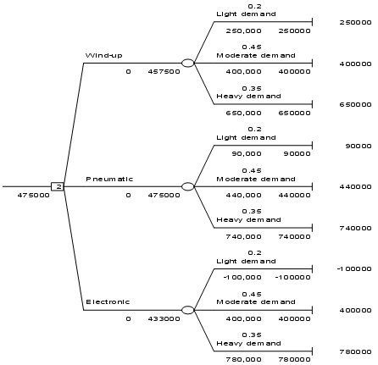

The best choice is Pneumatic, $475,000.
Diff: 2
Topic: Decision trees
AACSB: Analytic Skills
Objective: LO-Module A-6
82) A toy manufacturer has three different mechanisms that can be installed in a doll that it sells. The different mechanisms have three different setup costs (overheads) and variable costs and, therefore, the profit from the dolls is dependent on the volume of sales. The anticipated payoffs are as follows.

 | Light Demand | Moderate Demand | Heavy Demand
Probability | 0.25 | 0.45 | 0.3
Wind-up action | $325,000 | $190,000 | $170,000
Pneumatic action | $300,000 | $420,000 | $400,000
Electrical action | -$400,000 | $240,000 | $800,000

a. What is the EMV of each decision alternative?
b. Which action should be selected?
c. What is the expected value with perfect information?
d. What is the expected value of perfect information?
Answer: (a) Wind-up=.25*$325,000 + .45*$190,000 + .3*$170,000 = $217,750; Pneumatic =.25*$300,000 + .45*$420,000 + .3*$400,000 = $384,000; and Electrical = .25*(-$400,000) + .45*$240,000 + .3*$800,000 = $248,000. (b) Pneumatic has the best EMV, at $384,000. (c) EVwPI is .25*$325,000 + .45* $420,000 + .3* $800,000 = $510,250; (d) EVPI =$510,250 - $384,000 = $126,250.
Diff: 2
Topic: Types of decision-making environments
AACSB: Analytic Skills
Objective: LO-Module A-5

83) A local business owner is a bit uncertain of the demand forecast, and is timidly approaching the capacity decision for a business he is about to open. Here's how he describes the decisions that confront him over the next two years."First, I have to choose between building a large plant initially and building a small one that has room to expand. Or I could rent now, and decide whether to build next year. That one, too, could be the large version or the small. If I build small, then after one year, I can review how good business was, and decide whether to expand. If I build large, there is no further option to enlarge."Do not concern yourself with probabilities or payoff values .Simply draw the tree that illustrates the manager's decision alternatives and the chance events that go along with them. Use standard symbols for decision tree construction, and label all parts of your diagram carefully. To simplify, assume that business in the first year, and in the second, can be only "good" or "bad."
Answer:
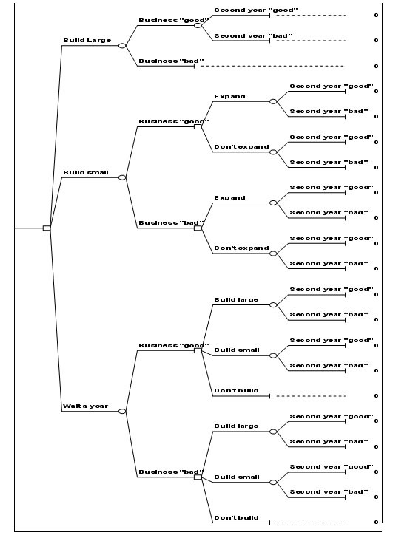
Diff: 2
Topic: Decision trees
AACSB: Analytic Skills
Objective: LO-Module A-7
84) Steve Gentry, the operations manager of Baja Fabricators, wants to purchase a new profiling machine (it cuts compound angles on the ends of large structural pipes used in the fabrication yard). However, because the price of crude oil is depressed, the market for such equipment is down. Steve believes that the market will improve in the near future and that the company should expand its capacity. The table below displays the three equipment options he is currently considering, and the profit he expects each one to yield over a two-year period. The consensus forecast at Baja is that there is about a 30% probability that the market will pick up "soon" (within 3 to 6 months) and a 70% probability that the improvement will come "later" (in 9 to 12 months, perhaps longer).

 | Profit from Capacity Investment (in Dollars)
Equipment Option | Market picks up "soon"  p = 0.30 | Market picks up "later"  p = 0.70
Manual Machine | -120000 | 210000
NC Machine | 140000 | 160000
CNC Machine | 200000 | -200000

a. Calculate the expected monetary value of each decision alternative.
b. Which equipment option should Steve take?
Answer: (a) The expected monetary values are: "Manual machine" $111,000, "NC Machine" $154,000, and "CNC Machine" -$80,000. (b) Based upon the EMV criterion, Baja should purchase an NC machine.
Diff: 1
Topic: Types of decision-making environments
AACSB: Analytic Skills
Objective: LO-Module A-4
85) Miles is considering buying a new pickup truck for his lawn service firm. The economy in town seems to be growing, and he is wondering whether he should opt for a subcompact, compact, or full-size pickup truck. The smaller truck would have better fuel economy, but would sacrifice capacity and some durability. A friend at the Bureau of Economic Research told him that there is a 30% chance of lower gas prices in his area this year, a 20% chance of higher gas prices, and a 50% chance that gas prices will stay roughly unchanged. Based on this information, Miles has developed a decision table that indicates the profit amount he would end up with after a year for each combination of truck and gas prices.

 | States of Nature
Alternatives | Lower gas prices | Gas prices unchanged | Higher gas prices
probability | .3 | .5 | .2
Subcompact | 16,000 | 21,000 | 23,000
Compact | 15,000 | 20,000 | 22,000
Full size | 18,000 | 19,000 | 6,000

Calculate the expected monetary value for each decision alternative. Which decision yields the highest EMV?
Answer: The expected values are: subcompact $19,900, compact $18,900, and full size $16,100. The highest EMV is that of the subcompact truck.
Diff: 2
Topic: Types of decision-making environments
AACSB: Analytic Skills
Objective: LO-Module A-4

86) Earl Shell owns his own Sno-Cone business and lives 30 miles from a beach resort. The sale of Sno-Cones is highly dependent upon his location and upon the weather. At the resort, he will profit $110 per day in fair weather, $20 per day in foul weather. At home, he will profit $70 in fair weather, $50 in foul weather. Assume that on any particular day, the weather service suggests a 60% chance of fair weather.
a. Construct Earl's payoff table.
b. What decision is recommended by the expected value criterion?
c. What is the EVPI?
Answer: (a)The payoff table is

Profit | Fair weather | Foul weather
 | Probability = 0.6 | Probability = .4
Sell at the resort | 110 | 20
Sell at home | 70 | 50

(b) the EMV for sell at the resort = .6*110 + .4*20 = 74; The EMV for sell at home = .6*70 + .3*50 = 62. The better value is $74, so Earl should sell at the resort.
(c) EVwPI = .6*110 + .4*50 = $86; EVPI = $86 - $74 = $12.

Diff: 2
Topic: Types of decision-making environments
AACSB: Analytic Skills
Objective: LO-Module A-5
87) The campus bookstore sells stadium blankets embroidered with the university crest. The blankets must be purchased in bundles of one dozen each. Each blanket in the bundle costs $65, and will sell for $90. Blankets unsold by homecoming will be clearance priced at $20. The bookstore estimates that demand patterns will follow the table below.
a. Build the decision table.
b. What is the maximum expected value?
c. How many bundles should be purchased?

Demand level | Probability
1 bundle | 10 percent
2 bundles | 30 percent
3 bundles | 50 percent
4 bundles | 10 percent

Answer: (a) See the table below; (b) the maximum expected value is $516; (c) the bookstore should order 2 bundles.

Profit | Demand 1 | Demand 2 | Demand 3 | Demand 4 |  | EMV
Probability | 0.1 | 0.3 | 0.5 | 0.1
Order 1 | 300 | 300 | 300 | 300 |  | 300
Order 2 | -240 | 600 | 600 | 600 | Maximum | 516
Order 3 | -780 | 60 | 900 | 900 |  | 480
Order 4 | -1320 | -480 | 360 | 1200 |  | 24

Diff: 2
Topic: Types of decision-making environments
AACSB: Analytic Skills
Objective: LO-Module A-4

88) Miles is considering buying a new pickup truck for his lawn service firm. The economy in town seems to be growing, and he is wondering whether he should opt for a subcompact, compact, or full-size pickup truck. The smaller truck would have better fuel economy, but would sacrifice capacity and some durability. A friend at the Bureau of Economic Research told him that there is a 30% chance of lower gas prices in his area this year, a 20% chance of higher gas prices, and a 50% chance that gas prices will stay roughly unchanged. Based on this information, Miles has developed a decision table that indicates the profit amount he would end up with after a year for each combination of truck and gas prices. Develop a decision tree for this situation and indicate which type of truck he should select.

 | States of Nature
Alternatives | Lower gas prices | Gas prices unchanged | Higher gas prices
probability | .3 | .5 | .2
Subcompact | 16,000 | 19,000 | 21,000
Compact | 15,000 | 20,000 | 22,000
Full size | 24,000 | 19,000 | 6,000
Answer: The tree appears in the drawing below. The highest expected value decision alternative is the compact truck, at $18,900, as shown in the POM for Windows solution.

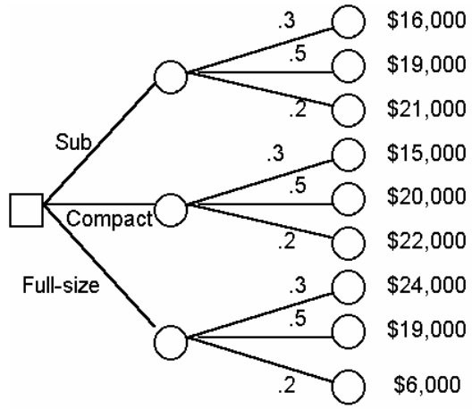

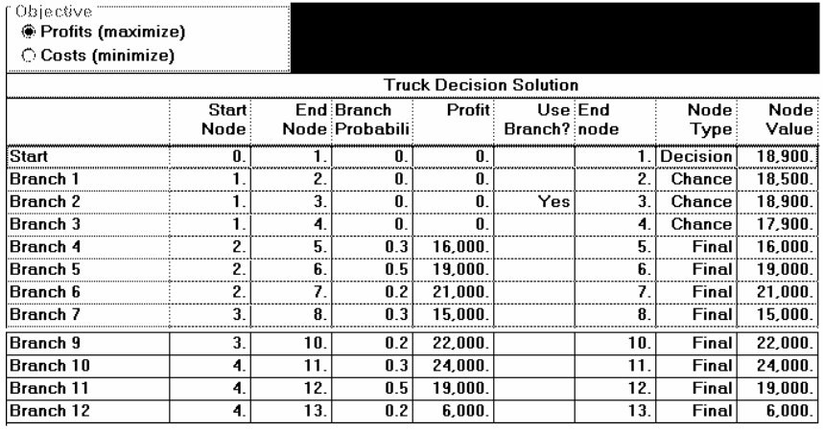
Diff: 1
Topic: Decision trees
AACSB: Analytic Skills
Objective: LO-Module A-6
89) Daily sales of bread by Salvador Monella's Baking Company follow the historical pattern shown in the table below. It costs the bakery 50 cents to produce a loaf of bread, which sells for 95 cents. Any bread unsold at the end of the day is sold to the parish jail for 25 cents per loaf. Construct the decision table of conditional payoffs. How many loaves should Sal bake each day in order to maximize contribution?

Demand | 400 | 500 | 600 | 700 | 800
Probability | .20 | .20 | .40 | .15 | .05

Answer: The Excel OM decision table and solution appear below. The best expected value is $228, which occurs with the decision to bake 600 loaves.

Profit | Sell 400 | Sell 500 | Sell 600 | Sell 700 | Sell 800 |  | EMV
Probability | 0.2 | 0.2 | 0.4 | 0.15 | 0.05
Bake 400 | 180 | 180 | 180 | 180 | 180 |  | 180
Bake 500 | 155 | 225 | 225 | 225 | 225 |  | 211
Bake 600 | 130 | 200 | 270 | 270 | 270 | Maximum | 228
Bake 700 | 105 | 175 | 245 | 315 | 315 |  | 217
Bake 800 | 80 | 150 | 220 | 290 | 360 |  | 195.5

Diff: 2
Topic: Types of decision-making environments
AACSB: Analytic Skills
Objective: LO-Module A-4
90) Earl Shell owns his own Sno-Cone business and lives 30 miles from a beach resort. The sale of Sno-Cones is highly dependent upon his location and upon the weather. At the resort, he will profit $120 per day in fair weather, $10 per day in bad weather. At home, he will profit $70 in fair weather, $55 in bad weather. Assume that on any particular day, the weather service suggests a 40% chance of foul weather.
a. Construct Earl's decision tree.
b. What decision is recommended by the expected value criterion?
Answer: Resort has a higher EMV ($76) than Home

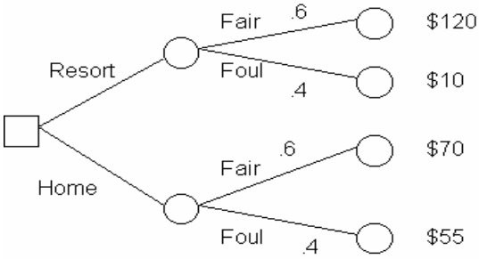

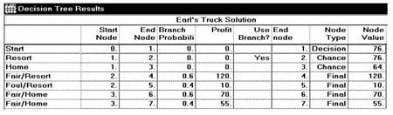
Diff: 2
Topic: Decision trees
AACSB: Analytic Skills
Objective: LO-Module A-6
91) The campus bookstore sells highlighters that it purchases by the case. Cost per case, including shipping and handling, is $200. Revenue per case is $350. Any cases unsold will be discounted and sold at $175. The bookstore has estimated that demand will follow the pattern below

Demand level | Probability
10 cases | 20 percent
11 cases | 20 percent
12 cases | 40 percent
13 cases | 15 percent
14 cases | 5 percent

a. Construct the bookstore's payoff table.
b. How many cases should the bookstore stock in order to maximize profit?
c. How would your answer differ if the clearance price were not $175 per case but $225 per case? (It is not necessary to re-solve the problem to answer this.)
Answer: (a) The Excel OM table is below. (b) The highest EMV is 1705, from stocking 13 cases. (c) If the clearance price exceeds the case cost, there will be no disincentive to stocking the maximum demand level, 14 cases.

Profit | Demand 10 | Demand 11 | Demand 12 | Demand 13 | Demand 14 |  | EMV
Probability | 0.2 | 0.2 | 0.4 | 0.15 | 0.05
Stock 10 | 1500 | 1500 | 1500 | 1500 | 1500 |  | 1500
Stock 11 | 1475 | 1650 | 1650 | 1650 | 1650 |  | 1615
Stock 12 | 1450 | 1625 | 1800 | 1800 | 1800 |  | 1695
Stock 13 | 1425 | 1600 | 1775 | 1950 | 1950 | Maximum | 1705
Stock 14 | 1400 | 1575 | 1750 | 1925 | 2100 |  | 1688.75

Diff: 2
Topic: Types of decision-making environments
AACSB: Analytic Skills
Objective: LO-Module A-4

92) Bratt's Bed and Breakfast, in a small historic New England town, must decide how to subdivide (remodel) the large old home that will become their inn. There are three alternatives: Option A would modernize all baths and combine rooms, leaving the inn with four suites, each suitable for two to four adults. Option B would modernize only the second floor; the results would be six suites, four for two to four adults, and two for two adults only. Option C (the status quo option) leaves all walls intact. In this case, there are eight rooms available, but only two are suitable for four adults, and four rooms will not have private baths. Below are the details of profit and demand patterns that will accompany each option. Which option has the highest expected value?

 | Annual profit under various demand patterns
 | Capacity | p | Average | p
A (Modernize all) | $90,000 | .5 | $25,000 | .5
B (Modernize 2nd) | $80,000 | .4 | $70,000 | .6
C (Status Quo) | $60,000 | .3 | $55,000 | .7
Answer: Branch 2, which represents Option B-Modernize 2nd floor, has the highest expected value, $74,000. This cannot be done as a decision table. POM for Windows solution follows.

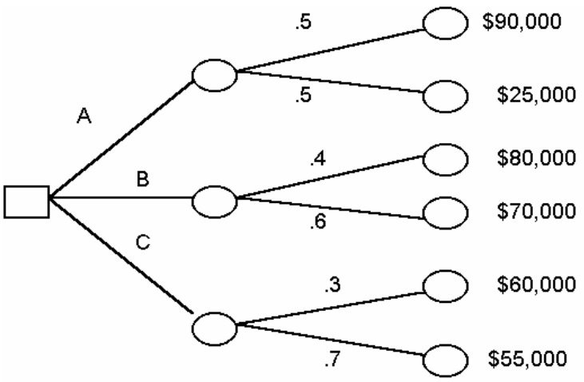

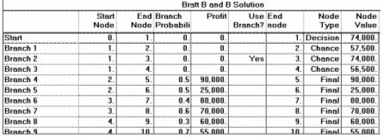
Diff: 2
Topic: Decision trees
AACSB: Analytic Skills
Objective: LO-Module A-6

93) A do-it-yourself homeowner is installing a new toilet. While installing the toilet he must decide on what kind of connecting pipe he will install to the water supply. There are two available options, one that has a shut-off valve in case of a leak and a cheaper one without the shut-off valve. Suppose that the shut-off valve pipe costs an extra ten dollars and that the homeowner must buy one of the two.
a. Draw a decision tree for this scenario, labeling the cost of a leak as X and the chance of a leak as P.
b. If the chance of a leak causing household damage is 1%, at what $ amount of household damage is the owner neutral on which pipe to buy?
c. If the cost of a leak would be $10,000 what is the maximum % chance to leak at which the homeowner would prefer to buy the cheaper pipe?
d. If the cost of a leak is $1,000 and the chance to flood .1% which pipe should the homeowner buy?
Answer:
a-
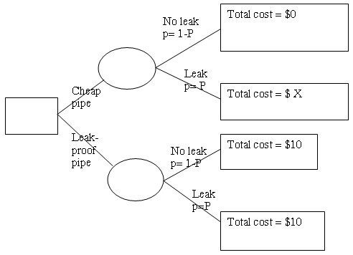

b- EMV of part B for the cheap pipe is .99(0)+.01(X), EMV for the leak-proof pipe is 10, set these equal to find the neutral value of X so .01X=10 and X=$1000
c- EMV of part C for the cheap pipe is (1-P)(0)+(P)(10,000), EMV for the leak-proof pipe is 10. Set these equal to find the maximum percent, so 10,000P=10 with P=.001
d- EMV of the cheap pipe is .999(0)+.001(1,000) which = $1 and the EMV of the leak-proof pipe is 10, so the homeowner should buy the cheaper pipe.
Diff: 2
Topic: Decision trees
AACSB: Analytic Skills
Objective: LO-Module A-6
94) Suppose a manufacturing plant is considering three options for expansion. The first one is to expand into a new plant (large) , the second to add on third-shift to the daily schedule (medium) , and the third to do nothing (small) . There are three possibilities for demand. These are high, medium, and low with each having an equal likelihood of occurring. Suppose that the profits for the expansion plans are as follows (respective to high, medium, low demand). The large expansion profits are $100000, $10000, -$10000, the medium expansion choice $40000, $40000, $5000 and the small expansion choice $15000, $15000, $15000. Calculate the EMV of each choice. Which of the expansion plans should the manager choose?
Answer: Student responses may include a decision tree to organize their thoughts (not required).
EMV large expansion is .33(100000) + .33(10000) + .33(-10000) = $33,333.33
EMV medium expansion is .33(40000) + .33 (40000) + .33(5000) = $28,333.33
EMV small expansion is $15,000
The plant manager should choose the large expansion.
Diff: 2
Topic: Decision trees
AACSB: Analytic Skills
Objective: LO-Module A-6

95) A poker player is considering three different options after his opponent bet 200 before him. If the player folds, he will lose instantly. If the player calls, he figures he will win half the time. If he raises he figures that the opposing player will not re-raise him, but rather will either call or fold. He figures the opposing player will call only ¼ of the time, folding the other ¾ of the time. If the opposing player calls his raise, he figures he will never win. The pot size is 1,000 (including the opposing player's bet).
a. Draw a decision tree for this scenario including the information provided in part b.
b. Suppose that the player is thinking of raising to $400 (he will put in 200 to match the opponent's bet and another 200 as a raise, his opponent would then have to put in 200 more to call the raise). Is this the best option or should he instead call or fold?
c. At what raise size is the player's EMV of a raise equivalent to simply calling?
Answer:
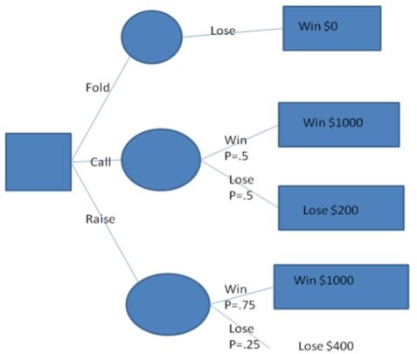

b- EMV of a fold is 0, EMV of a call is .5(1000) -.5(200) = 400, EMV of the raise is .75(1000) - .25 (400) = 650. The player should raise, not call or fold.
c- EMV of a call is 400 from above, EMV of a raise is .75(1000)-.25(Raise Size). Setting these equal so 400=.75(1000)-.25(Raise size) the raise size comes out to 1400.
Diff: 2
Topic: Decision trees
AACSB: Analytic Skills
Objective: LO-Module A-6

96) The EMV of a decision with three states of nature is $33,000. If the profit/value under the states of nature A, B, and C is $10,000, $20,000, and $50,000 and states B and C have equal probabilities, determine the likelihood of state of nature A.
Answer: 10*X+20*(.5-X/2)+50*(.5-X/2)=33. X=.08 => State of nature A has a 8% chance of occurring.
Diff: 3
Topic: Types of decision-making environments
AACSB: Analytic Skills
Objective: LO-Module A-4
97) The EMV of a decision with three states of nature is $50. If the profit/value of A is 1/3 of B and B is 1/3 of C, determine the profit from A if B and C have an equal chance of occurring that combined is twice the chance of A occurring.
Answer: The probabilities of all three states are equal from the question (1+1)/2=1. Thus the total payoff is simply the average of the three payoffs or 1/9+1/3+1= 13/27 if the value of C is 1. Solving for 13/27*C=50 gives C=$103.85. Thus A= $11.54. This problem could also be solved by setting the value of A to X and solving 50=(X+3X+3*3X)/3 to give X= $11.54 = A.
Diff: 2
Topic: Types of decision-making environments
AACSB: Analytic Skills
Objective: LO-Module A-4

